NARRATIVE CREW GENERATION

STRANGE CHARACTER
1 – 2 |  | 54 – 58
3 – 8 |  | 59 – 62
9 – 17 |  | 63 – 67
18 – 22 |  | 68 – 73
23 – 27 |  | 74 – 79
28 – 34 |  | 80 – 85
35 – 41 |  | 86 – 87
42 – 47 |  | 88 – 93
48 – 53 |  | 94 – 100
- Record each character’s basic profile along with any special rules and characteristics. Select your leader and grant them 1 Luck point.

STEP 1: ROLL FOR CREW TYPE (Five Parsecs - pgs. 14-23)
CREW TYPE
1 – 60
61 – 80
81 – 90
91 – 100

PRIMARY ALIEN
1 – 20
21 – 40
41 – 55
56 – 70
71 – 90
91 – 100

STEP 2: ROLL FOR BACKGROUND, MOTIVATION, AND CLASS (Five Parsecs - pgs. 24-27)
BACKGROUND
 | BACKGROUND | EFFECT |  | RESOURCES |  | STARTING ROLLS
1 – 4
5 – 9
10 – 13
14 – 17
18 – 21
22 – 25
26 – 29
30 – 34
35 – 39
40 – 42
43 – 46
47 – 49
50 – 52
53 – 55
56 – 59
60 – 64
65 – 68
69 – 72
73 – 76
77 – 80
81 – 84
85 – 89
90 – 93
94 – 97
98 – 100

MOTIVATION
 | MOTIVATION | EFFECT |  | RESOURCES |  | STARTING ROLLS
1 – 8
9 – 14
15 – 19
20 – 26
27 – 32
33 – 39
40 – 44
45 – 49
50 – 56
57 – 63
64 – 69
70 – 74
75 – 79
80 – 84
85 – 90
91 – 95
96 – 100

CLASS
 | CLASS | EFFECT |  | RESOURCES |  | STARTING ROLLS
1 – 5
6 – 9
10 – 13
14 – 17
18 – 22
23 – 27
28 – 32
33 – 36
37 – 40
41 – 44
45 – 49
50 – 54
55 – 58
59 – 63
64 – 67
68 – 71
72 – 75
76 – 79
80 – 83
84 – 88
89 – 92
93 – 96
97 – 100

STEP 3: ROLL FOR BACKSTORY (Ironsworn: Starforged - pg. 96)
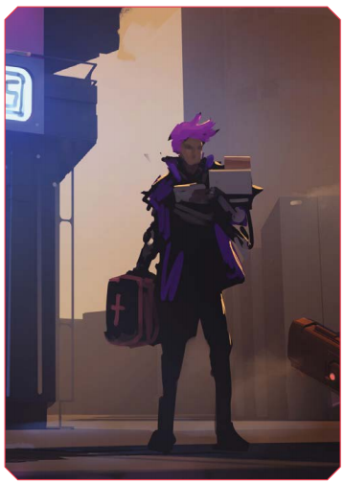
BACKSTORY PROMPTS
1 – 7
8 – 14
15 – 21
22 – 28
29 – 36
37 – 43
44 – 50
51 – 57
58 – 65
66 – 72
73 – 79
80 – 86
87 – 93
94 – 100

STEP 4: ROLL FOR BACKGROUND EVENTS (Every Star an Opportunity – pg. 11)
BACKGROUND EVENTS |  |  | ROLL 2 TIMES
1 – 3 | Betrayed by a friend | 49 – 51 | Illness or injury
4 – 6 | Lost love | 52 – 54 | Strong family ties
7 – 9 | Failed in a task | 55 – 57 | Saved someone
10 – 12 | Fell out with family | 58 – 60 | Solved a crime or injustice
13 – 15 | Death of someone | 61 – 63 | Championed a popular cause
16 – 18 | Framed for a crime | 64 – 66 | Had a lucky break
19 – 21 | Sided with unpopular cause | 67 – 69 | Peaceful
22 – 24 | Lost wealth | 70 – 72 | Travelled
25 – 27 | Met hero | 73 – 75 | Nearly died
28 – 30 | Mysterious event | 76 – 78 | Committed a crime
31 – 33 | War | 79 – 81 | Memories suppressed
34 – 36 | Made a great friend | 82 – 84 | Carried out a project
37 – 39 | Found love | 85 – 87 | Pointless drudgery
40 – 42 | Succeeded in a task | 88 – 90 | Living without a care
43 – 45 | Contact with aliens | 91 – 93 | Crushing poverty
46 – 48 | Captive | 94 – 100 | Run in with the authorities
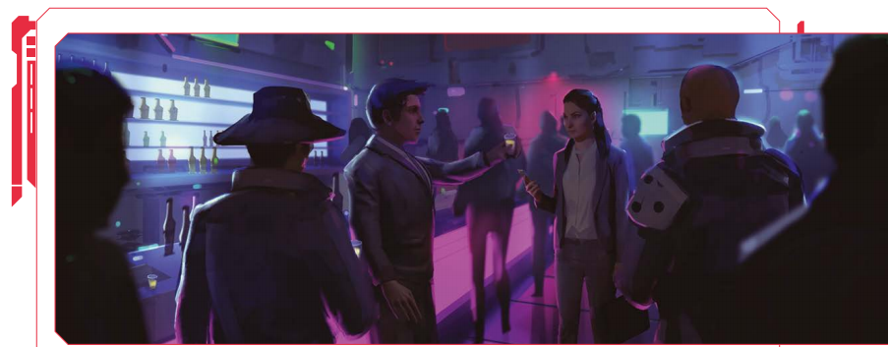

STEP 5: ROLL FOR FIRST LOOK/DISPOSITION (Ironsworn: Starforged - pg. 168)
AT FIRST LOOK |  |  |  |  | ROLL 2 TIMES
1 – 3 |  | 34 – 35 |  | 69 – 71
4 – 6 |  | 36 – 37 |  | 72 – 73
7 – 8 |  | 38 – 40 |  | 74 – 76
9 – 11 |  | 41 – 43 |  | 77 – 78
12 – 13 |  | 44 – 46 |  | 79 – 81
14 – 15 |  | 47 – 49 |  | 82 – 83
16 – 17 |  | 50 – 52 |  | 84 – 85
18 – 20 |  | 53 – 55 |  | 86 – 87
21 – 23 |  | 56 – 57 |  | 88 – 90
24 – 25 |  | 58 – 60 |  | 91 – 92
26 – 27 |  | 61 – 62 |  | 93 – 95
28 – 30 |  | 63 – 65 |  | 96 – 97
31 - 33 |  | 66 – 68 |  | 98 – 100
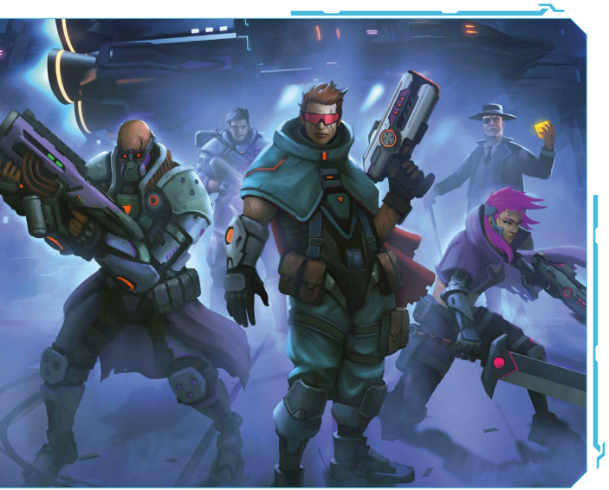
DISPOSITION
1 – 6 |  | 31 – 40 |  | 71 – 78
7 – 14 |  | 41 – 50 |  | 79 – 86
15 – 22 |  | 51 – 60 |  | 87 – 94
23 – 30 |  | 61 – 70 |  | 95 – 100

STEP 6: ROLL FOR CHARACTER NAMES/CALLSIGNS
 | FIRST NAME | LAST NAME | CALLSIGN |  |  | FIRST NAME | LAST NAME | CALLSIGN
1 | Akim | Kuzmin | Albatross |  | 51 | Jonas | Takara | Jester
2 | Alex | Durant | Angler |  | 52 | Jorunn | Shelton | Link
3 | Alonso | Jefferies | Anvil |  | 53 | Julian | Vandu | Longshot
4 | Andre | Valez | Badger |  | 54 | Juro | Vega | Mainframe
5 | Antoine | Lontoc | Bandit |  | 55 | Karthik | Zhang | Mantis
6 | Archer | Wade | Bash |  | 56 | Kenji | Savela | Mimic
7 | Argus | Kade | Basilisk |  | 57 | Klaus | Hawking | Mole
8 | Arnev | Thorn | Bingo |  | 58 | Kylar | Jen | Monarch
9 | Arvel | Khosia | Blackbird |  | 59 | Landon | Hobbs | Mongoose
10 | Ash | Hendrix | Blade |  | 60 | Landry | Holland | Nails
11 | Azriel | Okiro | Bloodshot |  | 61 | Leopold | Silvius | Ogre
12 | Baldur | Ripley | Bluewing |  | 62 | Logan | Freeman | Omega
13 | Blake | Talin | Bonfire |  | 63 | Lowell | Barbosa | Overload
14 | Boris | Jin | Book |  | 64 | Lucas | Winter | Packrat
15 | Brennan | Finn | Breaker |  | 65 | Luis | Hammond | Paladin
16 | Bruno | Solas | Brick |  | 66 | Magnus | Archer | Phantom
17 | Carrick | Quint | Buzz |  | 67 | Marco | Barlowe | Phoenix
18 | Cole | Keelan | Buzzard |  | 68 | Marcus | Shepherd | Pyro
19 | Constantin | Silva | Centurion |  | 69 | Marshal | Griffin | Quickdraw
20 | Conway | Valk | Chimera |  | 70 | Mattias | Frost | Razor
21 | Corey | O’Brien | Circuit |  | 71 | Merrick | Quon | Rogue
22 | Creed | Ruiz | Clank |  | 72 | Nassar | Malek | Rook
23 | Curtis | Stallard | Cleric |  | 73 | Nathaniel | Murad | Rover
24 | Damien | Mackenson | Crash |  | 74 | Nelson | Becker | Scout
25 | Dante | Jensen | Cutter |  | 75 | Omar | Ammar | Shadow
26 | Delmar | Sakir | Cutthroat |  | 76 | Oscar | Braddock | Shark
27 | Dex | Tolari | Cypher |  | 77 | Otto | Blackstone | Shutdown
28 | Dion | Kain | Dagger |  | 78 | Pascal | Hadley | Slack
29 | Donovan | Carr | Dancer |  | 79 | Pedro | Farin | Slag
30 | Doran | Valenus | Dash |  | 80 | Ragnar | Dyson | Snipe
31 | Draco | Kaan | Deadeye |  | 81 | Raiden | Duval | Spider
32 | Edgar | Taylan | Deuce |  | 82 | Rajeev | Hunter | Splinter
33 | Emilio | Legrand | Failsafe |  | 83 | Rami | Beckett | Static
34 | Emir | Jemison | Farseer |  | 84 | Rokuro | Dystra | Stinger
35 | Emmett | Arden | Fidget |  | 85 | Roland | Gray | Straggler
36 | Enzo | Sayer | Firestarter |  | 86 | Roland | Sedano | Swindle
37 | Feliks | Kai | Fixer |  | 87 | Roman | Bai | Tinker
38 | Fletcher | Slater | Flatline |  | 88 | Ross | Booker | Touchdown
39 | Flint | Edris | Ghost |  | 89 | Sergio | Sato | Tycoon
40 | Florian | Sutton | Grudge |  | 90 | Severinus | Vayan | Vagabond
41 | Gavin | Savarin | Gutshot |  | 91 | Shen | Bond | Valkyrie
42 | Gustavo | Bridger | Harrow |  | 92 | Shinji | Stark | Vanguard
43 | Hasan | Mital | Havoc |  | 93 | Stavros | Stirling | Vertigo
44 | Hiro | Shin | Hellhound |  | 94 | Viktor | Wolfe | Warden
45 | Ike | Nadir | Hellion |  | 95 | Vincent | O’Neil | Watchdog
46 | Isaac | Santos | Hex |  | 96 | Vuldar | Petrov | Wayfinder
47 | Ivan | Mihara | Hush |  | 97 | William | Nazari | Whisper
48 | James | Buhari | Ironclad |  | 98 | Wyatt | Darwin | Wraith
49 | Jarvis | Salvi | Jackal |  | 99 | Xavier | Pearson | Wrongway
50 | Javier | Adler | Jackpot |  | 100 | Zane | Volkov | Zephyr

 | FIRST NAME | LAST NAME | CALLSIGN |  |  | FIRST NAME | LAST NAME | CALLSIGN
1 | Adelaide | Morales | Burner |  | 51 | Kieran | Ahmed | Frostbite
2 | Alex | Yam | Shrapnel |  | 52 | Kierra | Kosta | Trip
3 | Alexis | McKay | Glitch |  | 53 | Kimora | Alvaro | Hazard
4 | Alina | Wong | Spike |  | 54 | Kiri | Rodriguez | Atlas
5 | Alisa | Abbot | Airwave |  | 55 | Kirsa | Takano | Buckshot
6 | Althea | Sims | Landslide |  | 56 | Kwan | Morena | Baron
7 | Amari | Shimamoto | Knight |  | 57 | Luna | Hancock | Nexus
8 | Ana | Lacoste | Riptide |  | 58 | Lux | Davenport | Gunner
9 | Annora | Osborne | Minotaur |  | 59 | Maeve | Glover | Empress
10 | Aparna | Wu | Odin |  | 60 | Maria | Rios | Checkmate
11 | Asha | Rey | Boomer |  | 61 | Mareike | Miyashiro | Renegade
12 | Astrid | Richards | Hammer |  | 62 | Marsala | Park | Manticore
13 | Aurora | Talbot | Meatball |  | 63 | Meghan | Xu | Bishop
14 | Ayako | Noble | Jazz |  | 64 | Melani | Barone | Vortex
15 | Birgitte | Cline | Vector |  | 65 | Mina | Bowman | Tomahawk
16 | Brianna | Ortiz | Mako |  | 66 | Ming-na | Russell | Toast
17 | Bruna | Ono | Echo |  | 67 | Miyuki | Klein | Nano
18 | Camille | Velez | Crusher |  | 68 | Nadira | Kozlow | Switchblade
19 | Cassidy | Reed | Nightingale |  | 69 | Naomi | Romano | Zombie
20 | Claudia | Metzger | Shark |  | 70 | Nashida | Owen | Nova
21 | Crysta | Hayakawa | Zed |  | 71 | Natalya | Cobb | Pitbull
22 | Derya | Monaco | Duke |  | 72 | Natsuko | Russo | Nitro
23 | Dex | Hardy | Blackjack |  | 73 | Nora | Ivanoff | Siren
24 | Echo | Sakamoto | Blitz |  | 74 | Octavia | Sandoval | Falcon
25 | Edeline | Simpson | Doc |  | 75 | Oksana | Fowler | Cash
26 | Elena | Cross | Dice |  | 76 | Ostara | Leblanc | Angel
27 | Elise | Murcia | Apex |  | 77 | Qasira | Hale | Slim
28 | Elsie | Dodson | Axle |  | 78 | Quinn | Blake | Gecko
29 | Eren | Tsuji | Voodoo |  | 79 | Raven | Decker | Rhino
30 | Erim | Bell | Crossfire |  | 80 | Ria | Pena | Gypsy
31 | Esana | Nunez | Chef |  | 81 | Rowena | Hardin | Domino
32 | Eveline | Morgan | Nomad |  | 82 | Sage | Yan | Dingo
33 | Faye | Fortino | Shade |  | 83 | Samira | Pratt | Cowboy
34 | Gabriele | Dorado | Diablo |  | 84 | Saren | Maisto | Prophet
35 | Gia | Townsend | Javelin |  | 85 | Sigrid | Fontana | Tripwire
36 | Halia | Dixon | Tempest |  | 86 | Sofia | Wilkins | Cargo
37 | Isabelle | Sparks | Ace |  | 87 | Talia | Murphy | Warlock
38 | Jade | Krueger | Stalker |  | 88 | Tomiko | Campos | Condor
39 | Janna | Hood | Psycho |  | 89 | Valda | Navarro | Scotch
40 | Janya | Watson | Grinder |  | 90 | Valeria | Cortez | Gear
41 | Jocelyn | Cameron | Zealot |  | 91 | Venri | Cartier | Widow
42 | Juliana | Brooks | Nemesis |  | 92 | Vesper | Lawrence | Templar
43 | Kaisa | Daniels | Reaper |  | 93 | Vivi | Ayers | Nuke
44 | Kamelia | Avery | Freefall |  | 94 | Yelena | Rhodes | Bonzai
45 | Kari | Pavlovich | Quake |  | 95 | Yvette | Safar | Twitch
46 | Katarina | Del Rio | Gryphon |  | 96 | Yvonne | Jacobson | Gadget
47 | Kate | Ishikawa | Onyx |  | 97 | Zakia | Mosley | Lockdown
48 | Katja | Novak | Delta |  | 98 | Zari | Mckee | Outlaw
49 | Kayla | Bosco | Tilt |  | 99 | Zephyr | Higgins | Torch
50 | Kiana | Scali | Diesel |  | 100 | Zoya | Myers | Tank
GEARING UPS
STEP 7: ROLL FOR EQUIPMENT (Five Parsecs - pgs. 28-29)
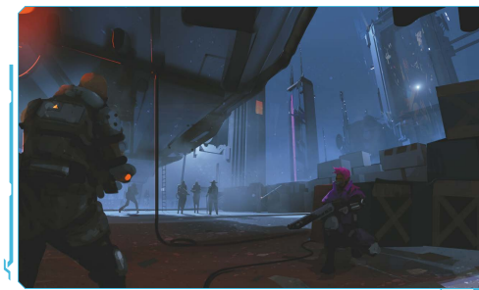
- 3 rolls on the Military Weapon Table. For each crewmember with at least one Savvy increase, you may take one of these rolls on the High-tech Weapon Table instead, if desired.
- 3 rolls on the Low-tech Weapon Table.
- 1 roll on the Gear Table.
- 1 roll on the Gadget Table.
- 1 credit per crew member.

GEAR
1 – 4
5 – 10
11 – 15
16 – 20
21 – 24
25 – 28
29 – 33
34 – 37
38 – 42
43 – 46
47 – 52
53 – 57
58 – 61
62 – 65
66 – 69
70 – 75
76 – 81
82 – 85
86 – 89
90 – 92
93 – 96
97 – 100

GADGET
1 – 4
5 – 9
10 – 13
14 – 17
18 – 21
22 – 24
25 – 27
28 – 31
32 – 36
37 – 41
42 – 46
47 – 50
51 – 55
56 – 60
61 – 65
66 – 69
70 – 73
74 – 79
80 – 83
84 – 89
90 – 93
94 – 100

LOW-TECH WEAPON
1 – 15
16 – 35
36 – 40
41 – 65
66 – 75
76 – 80
81 – 95
96 – 100

MILITARY WEAPON
1 – 25
26 – 45
46 – 50
51 – 60
61 – 75
76 – 80
81 – 95
96 – 100
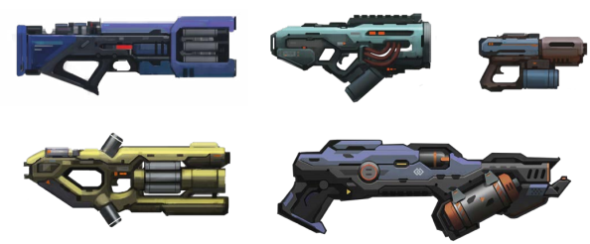
- All weapons are detailed on pages 50 – 52.
- All equipment is detailed on pages 53 – 58.
HIGH-TECH WEAPON
1 - 5
6 – 15
16 – 30
31 – 45
46 – 55
56 – 70
71 – 80
81 – 85
86 – 100

YOUR STARSHIP
Emergency Drives:
Fuel Efficient:
Fuel Hog:
Standard Issue:
Dodgy Drive:
Armored:
STEP 8: ROLL FOR SHIP DETAILS (Five Parsecs - pg. 31)
BACKGROUND
 | SHIP | DEBT |  | HULL |  | TRAITS
1 – 12
13 – 18
19 – 23
24 – 31
32 – 38
39 – 45
46 – 56
57 – 65
66 – 70
71 – 76
77 – 84
85 – 95
96 – 100

STEP 9: ROLL FOR SHIP NAME (Ironsworn: Starforged - pg. 167)
STARSHIP NAME
1 |  | 26 |  | 51 |  | 76
2 |  | 27 |  | 52 |  | 77
3 |  | 28 |  | 53 |  | 78
4 |  | 29 |  | 54 |  | 79
5 |  | 30 |  | 55 |  | 80
6 |  | 31 |  | 56 |  | 81
7 |  | 32 |  | 57 |  | 82
8 |  | 33 |  | 58 |  | 83
9 |  | 34 |  | 59 |  | 84
10 |  | 35 |  | 60 |  | 85
11 |  | 36 |  | 61 |  | 86
12 |  | 37 |  | 62 |  | 87
13 |  | 38 |  | 63 |  | 88
14 |  | 39 |  | 64 |  | 89
15 |  | 40 |  | 65 |  | 90
16 |  | 41 |  | 66 |  | 91
17 |  | 42 |  | 67 |  | 92
18 |  | 43 |  | 68 |  | 93
19 |  | 44 |  | 69 |  | 94
20 |  | 45 |  | 70 |  | 95
21 |  | 46 |  | 71 |  | 96
22 |  | 47 |  | 72 |  | 97
23 |  | 48 |  | 73 |  | 98
24 |  | 49 |  | 74 |  | 99
25 |  | 50 |  | 75 |  | 100

STEP 10: ROLL FOR STARSHIP HISTORY AND ENVISIONING (Ironsworn: Starforged - pgs. 98-99)
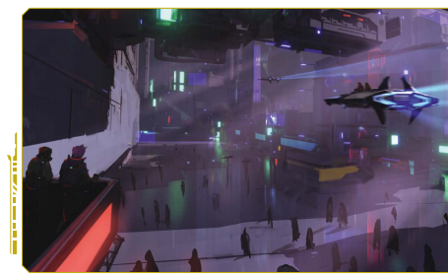
STARSHIP HISTORY
1 – 8
9 – 17
18 – 25
26 – 34
35 – 42
43 – 50
51 – 58
59 – 67
68 – 75
76 – 84
85 – 92
93 – 100

STARSHIP DETAILS
1 – 5
6 – 10
11 – 15
16 – 20
21 – 25
26 – 30
31 – 35
36 – 40
41 – 45
46 – 50
51 – 55
56 – 60
61 – 65
66 – 70
71 – 75
76 – 80
81 – 85
86 – 90
91 – 95
96 – 100
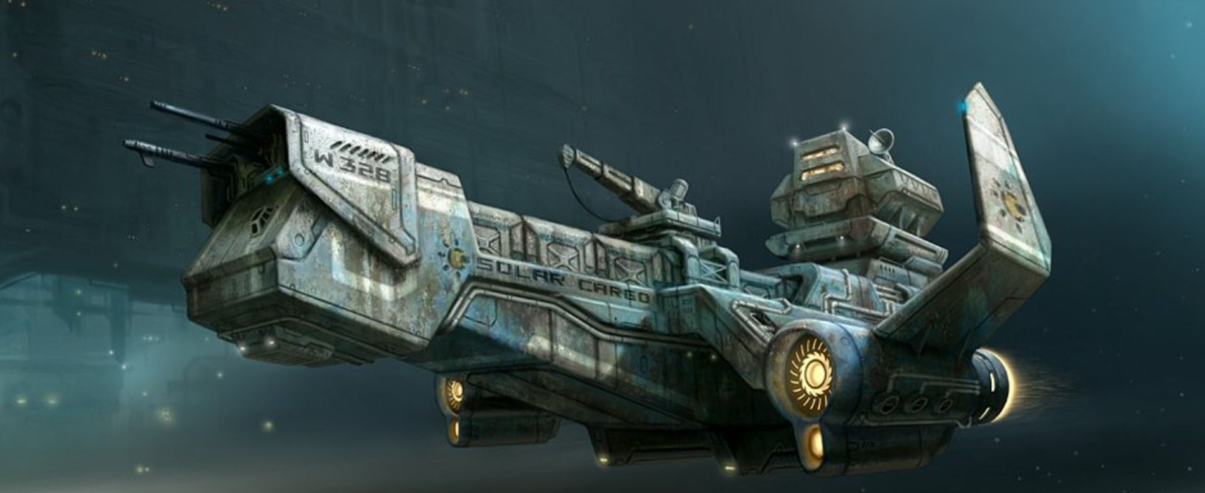

CREW FINISHING TOUCHES
STEP 11: ROLL FOR FLAVOR DETAILS (Five Parsecs - pg. 32)
WE MET THROUGH… |  | WE ARE BEST CHARACTERIZED AS…
1 – 10 |  | 1 – 12
11 – 20 |  | 13 – 21
21 – 30 |  | 22 – 28
31 – 40 |  | 29 – 34
41 – 50 |  | 35 – 48
51 – 65 |  | 49 – 58
66 – 75 |  | 59 – 72
76 – 90 |  | 73 – 87
91 – 100 |  | 88 – 100

RIVAL
1 – 50
51 - 80
81 - 100

STEP 12: ROLL FOR ANY STARTING PATRON/RIVALS (Five Parsecs - pgs. 83-84, 94-100)
PATRON
 | PATRON IS |  | NOTES
1 – 2
3 – 4
5
6 – 7
8 – 9
10

CRIMINAL ELEMENTS |  | HIRED MUSCLE |  | INTERESTED PARTIES
1 – 10 |  | 1 – 14 |  | 1 – 6
11 – 19 |  | 15 – 26 |  | 7 – 13
20 – 27 |  | 27 – 34 |  | 14 – 18
28 – 34 |  | 35 – 39 |  | 19 – 27
35 – 43 |  | 40 – 42 |  | 28 – 35
44 – 48 |  | 43 – 46 |  | 36 – 41
49 – 51 |  | 47 – 50 |  | 42 – 48
52 – 57 |  | 51 – 53 |  | 49 – 52
58 – 64 |  | 54 – 59 |  | 53 – 56
65 – 71 |  | 60 – 64 |  | 57 – 63
72 – 79 |  | 65 – 74 |  | 64 -68
80 – 83 |  | 75 – 79 |  | 69 – 72
84 - 90 |  | 80 – 85 |  | 73 – 76
91 – 94 |  | 86 – 90 |  | 77 – 83
95 - 100 |  | 91 - 95 |  | 84 – 88
 |  | 96 – 100 |  | 89 -100

STEP 13: NAME PATRONS/RIVALS
PATRONS
PATRON - CORPORATIONS |  |  |  |  |  |  | ROLL PREFIX & SUFFIX
Roll | Prefix | Suffix |  |  | Roll | Prefix |  | Suffix
1 – 2 | Aeon | Aerospace |  |  | 51 – 52 | Nova |  | Holdings
3 – 4 | Ajax | Applications |  |  | 53 – 54 | Odyssey |  | Incorporated
5 – 6 | Apex | Armaments |  |  | 55 – 56 | Omega |  | Industries
7 – 8 | Arclight | Bionics |  |  | 57 – 58 | Oracle |  | Interplanetary
9 – 10 | Arcturus | Biotech |  |  | 59 – 60 | Paragon |  | Interstellar
11 – 12 | Ares | Cargo |  |  | 61 – 62 | Phoenix |  | Laboratories
13 – 14 | Argus | Chemical |  |  | 63 – 64 | ProtoCom |  | Limited
15 – 16 | Artemis | Communications |  |  | 65 – 66 | Renegade |  | Logistics
17 – 18 | Bastion | Consolidated |  |  | 67 – 68 | Rosenkov |  | Machines
19 – 20 | Bell | Construction |  |  | 69 – 70 | Sentinel |  | Manufacturing
21 – 22 | Blackrock | Corp |  |  | 71 – 72 | Seraph |  | Media Group
23 – 24 | Chiron | Cryonics |  |  | 73 – 74 | Shima |  | Mercantile
25 – 26 | CyTek | Cybernetics |  |  | 75 – 76 | Sirius |  | Mining
27 – 28 | Defiance | Defense |  |  | 77 – 78 | Spartan |  | Motors
29 – 30 | Drake | Development |  |  | 79 – 80 | Syntex |  | Nanotech
31 – 32 | Dyson | Dynamics |  |  | 81 – 82 | TeraCom |  | Networks
33 – 34 | Frontier | Energy |  |  | 83 – 84 | Terra |  | Pharmaceuticals
35 – 36 | Hades | Engineering |  |  | 85 – 86 | Thanatos |  | Research
37 – 38 | Hermes | Enterprises |  |  | 87 – 88 | Theta |  | Securities
39 – 40 | Icarus | Exports |  |  | 89 – 90 | Titan |  | Shipping
41 – 42 | Infinity | Fabrication |  |  | 91 – 92 | Trinity |  | Solutions
43 – 44 | Kronos | Financial |  |  | 93 – 94 | Tycho |  | Supplies
45 – 46 | Kruger | Galactic |  |  | 95 – 96 | Unity |  | Systems
47 – 48 | Lonestar | Genetics |  |  | 97 – 98 | Watanabe |  | Technologies
49 – 50 | NEXT | Genomics |  |  | 99 – 100 | Weyland |  | Transorbital

PATRON – PRIVATE ORGANIZATIONS |  |  |  |  |  |  | ROLL PREFIX & SUFFIX
Roll | Prefix | Suffix |  |  | Roll | Prefix |  | Suffix
1 – 10 | Blackstone | Alliance |  |  | 51 – 60 | Janus |  | Foundation
11 – 20 | Cerberus | Association |  |  | 61 – 70 | Millenium |  | Group
21 – 30 | Dharma | Consortium |  |  | 71 – 80 | Monarch |  | Holdings
31 – 40 | Epsilon | Cooperative |  |  | 81 – 90 | Nakamura |  | Initiative
40 – 50 | Horizon | Council |  |  | 91 – 100 | Nostromo |  | Society

PATRON – SECRETIVE GROUPS
1 – 5 | Ad Astra | 26 – 30 | Chimera | 51 – 55 | Helsing Institute | 76 – 80 | Seventh Legion
6 – 10 | Ark | 31 – 35 | Court of Eyes | 56 – 60 | Nightfall | 81 – 85 | Starfarers
11 – 15 | Ascended, The | 36 – 40 | Covenant | 61 – 65 | NOMAD | 86 – 90 | TENET
16 – 20 | Awakened, The | 41 – 45 | Division, The | 66 – 70 | Section 23 | 91 – 95 | Veritas
21 – 25 | Blue Crow | 46 – 50 | Fulcrum | 71 – 75 | Seekers, The | 96 - 100 | Vigil, The

RIVALS
RIVAL – CRIMINAL ELEMENTS
1 – 5 | The 66 | 51 – 55 | Raging Circle
6 – 10 | Alley Katz | 56 – 60 | Razor Maulers
11 – 15 | Asphalt Justice | 61 – 65 | Reapers
16 – 20 | Capitol Convicts | 66 – 70 | Roaring Rats
21 – 25 | Chrome Cutters | 71 – 75 | The Five-by-Five
26 – 30 | Desperados | 76 – 80 | The Lunatics
31 – 35 | Forsaken | 81 – 85 | The Runners
36 – 40 | Gutter Barons | 86 – 90 | Vandals
41 – 45 | Metal Misfits | 91 – 95 | Voodoo Sinners
46 – 50 | Pink Fists | 96 – 100 | Warlocks

RIVAL – HIRED MUSCLE
1 – 5 | Blue Moon | 51 – 55 | Bulwark
6 – 10 | ComStar | 56 – 60 | Third Hand
11 – 15 | Crusaders | 61 – 65 | Black Company
16 – 20 | OMNI | 66 – 70 | Second Sun
21 – 25 | Legionnaires | 71 – 75 | 531st Voidborne
26 – 30 | Sentinels | 76 – 80 | ARES Defense
31 – 35 | TerraSec | 81 – 85 | Redshift
36 – 40 | Dark Sun | 86 – 90 | WARDEN
41 – 45 | AEGIS | 91 – 95 | Saints
46 – 50 | Manticore | 96 – 100 | Vanguard

RIVAL – INTERESTED PARTIES |  | ROLL PREFIX & SUFFIX
ROLL | PREFIX | ROLL | SUFFIX
1 – 5 | Morgan's | 1 – 5 | Liquidators
6 – 10 | Hammerhead's | 6 – 10 | Hunters
11 – 15 | Spike's | 11 – 15 | Raiders
16 – 20 | Bart's | 16 – 20 | Runners
21 – 25 | Pinky's | 21 – 25 | Misfits
26 – 30 | Malcolm's | 26 – 30 | Reapers
31 – 35 | Burke's | 31 – 35 | Crew
36 – 40 | Cobb's | 36 – 40 | Riders
41 – 45 | Miley's | 41 – 45 | Salvagers
46 – 50 | Gizmo's | 46 – 50 | Wanderers
51 – 55 | Sal's | 51 – 55 | Rebels
56 – 60 | Zedd's | 56 – 60 | Squad
61 – 65 | Badger's | 61 – 65 | Corps
66 – 70 | Niska's | 66 – 70 | Posse
71 – 75 | Hobbs' | 71 – 75 | Bandits
76 – 80 | Gak's | 76 – 80 | Freebooters
81 – 85 | Beck's | 81 – 85 | Marauders
86 – 90 | Renton's | 86 – 90 | Privateers
91 – 95 | Jace's | 91 – 95 | Rustlers
96 – 100 | Lana's | 96 – 100 | Looters

