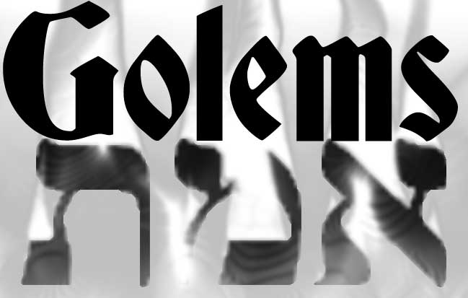

By Lloyd Krassner (kraz@Bellsouth.net)

GOLEMS
By Lloyd Krassner (kraz@Bellsouth.net)

INTRODUCTION
Fantasy Wargame for 2-4 players.
You are a mighty Wizard.
Use your Magic to make Golems to defeat you enemies.

VICTORY
Destroy all opposing Wizards.

DICE, CHITS, COUNTERS, TILES, COINS, & CARDS
Ten sided dice are needed to play.
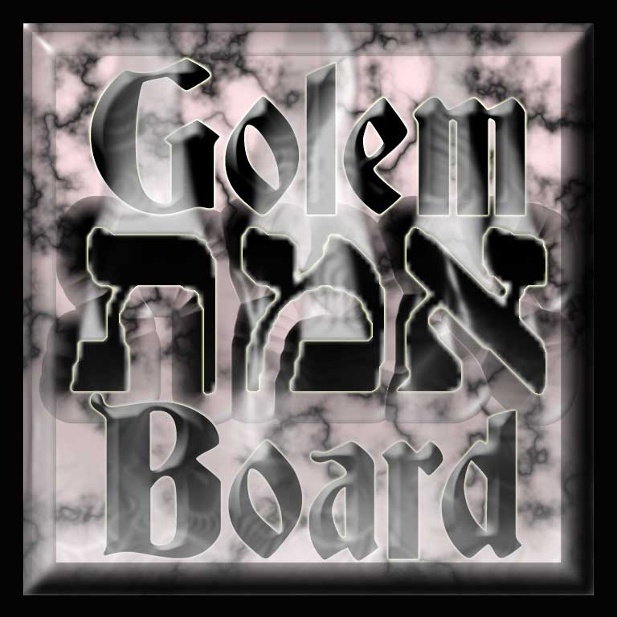
Tiles are used to make the Map.
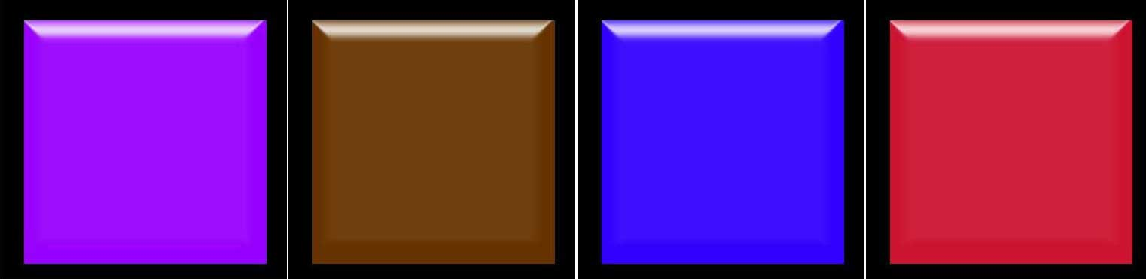
Each player has a set of numbered chits of a unique color.
Numbered Chits are used to represent Golems.
Cards are used for 2 Decks:
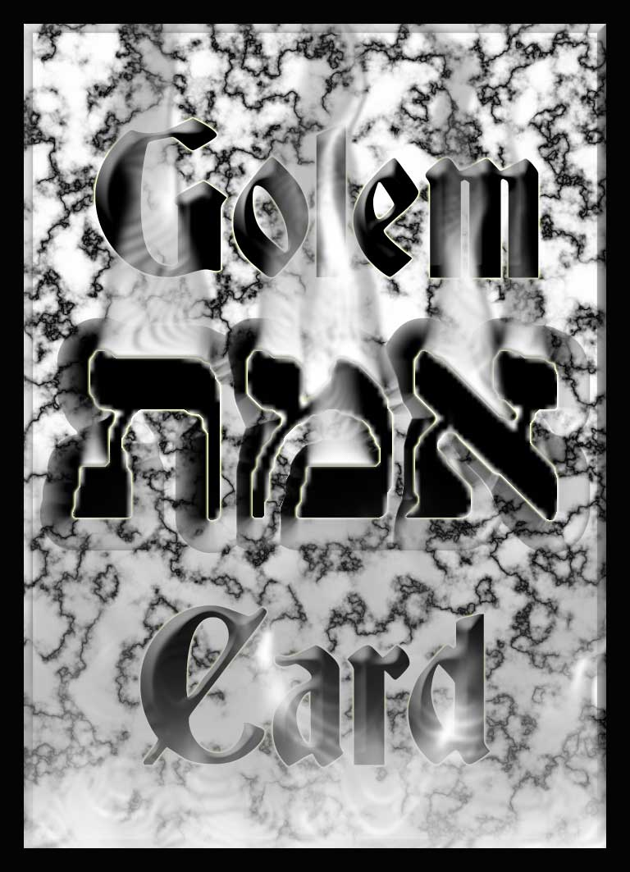
The Golem Deck
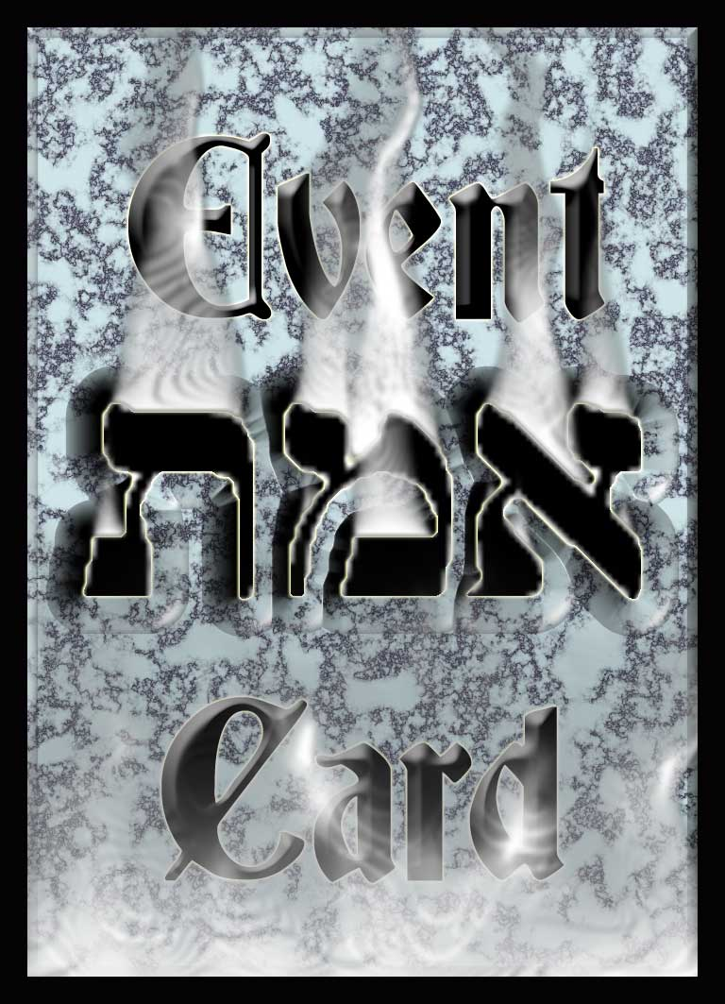
the Event Deck
Coins represent Mana.

Counters are placed on
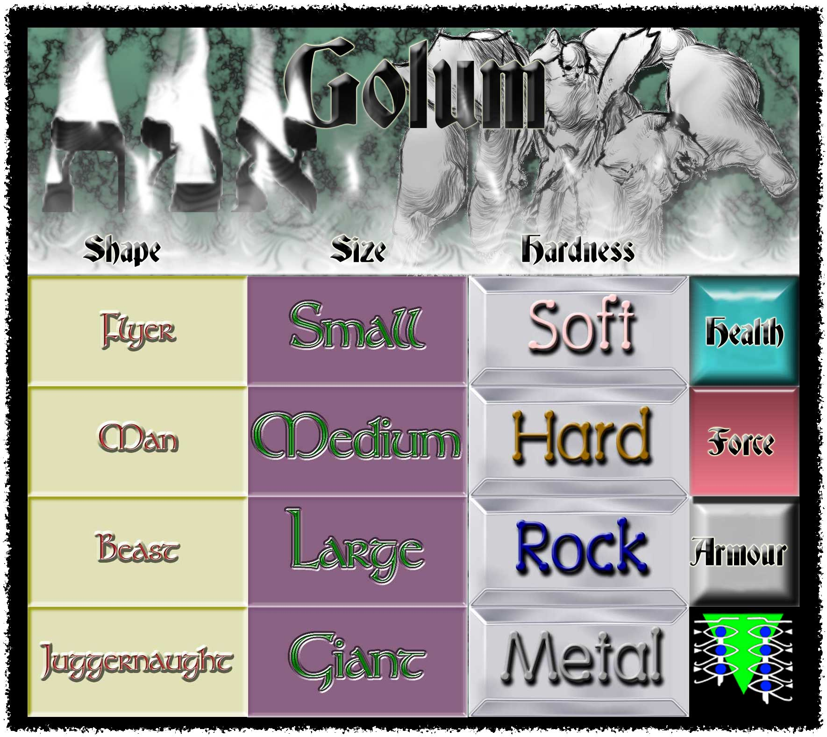
Golem Status Cards to record damage.

TERRAIN TILE LIST
Terrain Type: | # | Notes:
Tower | 4 | One in each Corner: Mana +1
Village | 1 | Needed to recruit Flesh Golems
Mud Flats | 1 | Needed to recruit Clay Golems
Quarry | 1 | Needed to recruit Stone Golems
Gem Mine | 1 | Needed to recruit Crystal Golems
Iron Mine | 1 | Needed to recruit Iron Golems
Ice Cave | 1 | Needed to recruit Ice Golems
Gold Mine | 1 | Needed to recruit Gold Golems
Ruins | 1 | Needed to recruit Bone Golems
Desert | 1 | Needed to recruit Sand Golems
Forest | 1 | Needed to recruit Wood Golems
Hills | 1 | Needed to recruit Bronze Golems
Mountain | 1 | Needed to recruit Obsidian Golems
Salt Flats | 1 | Needed to recruit Salt Golems
Workshops | 1 | Needed to recruit Clockwork Golems
Silver Mine | 1 | Needed to recruit Silver Golems
Volcano | 1 | Needed to recruit Basalt Golems
Monolith | 8 | Mana +1
Water | 12 | Barrier to Movement
Wasteland | 24

THE MAP
Use a Chessboard.
Each space is known as a Territory.
The corner spaces are Towers.
Randomly distribute the remaining 60 Terrain Tiles.

SETUP
Each Player starts in control of 1 Tower.
Players start with 20 Mana.
Each player gets dealt 6 Golem cards & 3 Event cards.
Randomly determine who goes first.
Your Tower Contains your Wizard who does not move.
A Wizard is small, soft, man-shaped, has 5 Hits, Force +7, and Armor +7.
The Wizard may freely stack with Golems in the Tower.

TURN SEQUENCE
Players take turns.
Each turn has 7 phases:
- Power Phase
- Craft Phase
- Fate Phase
- Spell Phase
- Move Phase
- Battle Phase
- End Phase

1. POWER PHASE
Gain 4 Mana.
Gain 1 extra Mana for each Monolith & each Tower space you occupy.
Mana is used to make Golems, cast Spells, and draw extra cards.
Mana may be saved from turn to turn.

2. CRAFT PHASE
You may build a Golem in this phase.
Play 1 Material, 1 Size, and 1 Shape card.
Calculate the Hits, Move, Force, & Armor of your Golem.
You must control certain spaces to use certain Material cards.
If you do not control the appropriate materials space, you can
still craft the Golem, but it costs double Mana.
A Units cost to build, in Mana, is equal to its Force + Hits.
Represent the Golem with a numbered chit from your color set.
Record the ID number & stats for the new Golem.
Place the chit on or adjacent to your Tower.
Discard played cards.

3. FATE PHASE
Draw 3 cards in any combination from the Event Deck &/or Golem Deck.
Each player maintains 2 separate hands: an Event card hand & a Golem card hand.
Max hand size is 7 cards (for each hand). Discard excess cards.
If a deck runs out, shuffle the discard and draw from it.
Pay 5 Mana to draw an extra card from either deck.

4. SPELL PHASE
All players may play Spell cards.
All Spell cards cost 2 Mana each to play.
Spell cards are discarded after being played.

5. MOVE PHASE
You may move some, none, or all of you units.
Units can move up to 1 to 4 spaces depending on their shape
Units cannot enter or move through Water spaces.
Exception: Flying units may pass through water spaces.
Units cannot move through other units, except for flying units.
The stacking limit must be strictly enforced.
Some Spell cards will affect the Movement of units & Stacks.

ADJACENCY RULE
Units or spaces must share a common border to be adjacent.
Diagonal spaces and units are not adjacent.

CONTROL OF SPACES
For purpose of access to Materials needed to build Golems.
One of your golems must occupy the space or
The space must be empty, and you must have a golem adjacent to it.

STACKING RULE
In a single space you may stack up to 4 golems.
No two Golems in a stack may have the same size, shape, or hardness.
(2 Golems with the same trait will destroy each other)
Units from opposing players cannot occupy the same space.

6. BATTLE PHASE
You may attack adjacent enemy stacks with your own stacks.
Resolve conflicts between two opposing stacks, one at a time.
A turn may have multiple battles between multiple stacks.
Battles are fought in Rounds.
Player may play Battle cards at any time during the round.
During each round, each Golem, in turn, in both opposing stacks gets to attack once.
Small units always attack before Medium size & Large units.
Medium size units always attack before Large units.
Start with the Active player (Player whose turn it is)
Pick which of your golems is attacking, and what its target is.
Both players roll 1D10.
The attacker adds the attacking golems Force modifier.
The defender adds the target golems Armor modifier
If the Attackers modified roll is equal or higher, the Target loses 1 hit.
A golem reduced to zero hits is destroyed & discarded.
The other player then attacks and so on.
This repeats until one side is completely eliminated.
Extra Attacks (From Battle Cards) are made, in turn, like regular attacks.
Units in Towers get Armor +1.

7. END PHASE
If you won a battle, you may put any of your Soft Golems that
were killed in the battle back into play. (They Regenerate)

GOLEM DECK CARD LIST
Card Name: | Type | Hard | Force | Armor | #
Flesh | M | S | +1 | - | 1
Clay | M | S | +1 | - | 1
Stone | M | R | +3 | +2 | 1
Crystal | M | R | +3 | +2 | 1
Iron | M | M | +4 | +3 | 1
Ice | M | H | +2 | +1 | 1
Gold | M | M | +4 | +3 | 1
Bone | M | H | +2 | +1 | 1
Sand | M | S | +1 | - | 1
Wood | M | H | +2 | +1 | 1
Bronze | M | M | +4 | +3 | 1
Obsidian | M | R | +3 | +2 | 1
Basalt | M | R | +3 | +2 | 1
Clockwork | M | H | +2 | +1 | 1
Salt | M | S | +1 | - | 1
Silver | M | M | +4 | +3 | 1
Card Name: | Type | Hits | Force | Armor | #
Small | Z | 1 | - | +1 | 4
Medium | Z | 2 | +1 | +2 | 4
Large | Z | 3 | +2 | +3 | 4
Giant | Z | 4 | +3 | +4 | 4
Card Name: | Type | Move | Force | Armor | #
Man | S | 2 | - | - | 4
Beast | S | 3 | +1 | - | 4
Flyer | S | 4 | - | -1 | 4
Juggernaught | S | 1 | +1 | +1 | 4

Types:
M = Materials, Z = Size, S = Shape
Hard (hardness):
S = Soft, H = Hard, R = Rock, M = Metal
# = Number of copies in the deck

EVENT DECK CARD LIST
Event: | Type | Notes:
Swoop | B | Target Flyer gets extra Attack this Round
Maul | B | Target Beast gets extra Attack this Round
Club | B | Target Man gets extra Attack this Round
Crush | B | Target Juggernaught gets extra Attack this Round
Dodge | B | Target Small or Medium Golem gets +7 Armor
Fast Attack | B | Target Small or Medium gets extra Attack this Round
Great Bulk | B | Target Large or Giant Golem gets +5 Armor
Stomp | B | Target Large or Giant gets extra Attack this Round
Splatter | B | Attack vs Soft Target is +5 Force
Shatter | B | Attack vs Hard Target is +5 Force
Crumble | B | Attack vs Rock Target is +5 Force
Crack | B | Attack vs Metal Target is +5 Force
Haste | S | Target Stack may move twice this Turn
Ritual Mana | S | Gain 7 Mana
Elemental Storm | S | One Force +3 Attack vs each Golem in Stack
Power | S | Golems in Stack get +1 Force for 2 turns
Protection | S | Golems in Stack get +1 Armor for 2 turns
Portal | S | Move your target Stack to any empty space
Divination | S | Look at opponents hands & next 7 cards in decks
Dispell | S | Negate Spell just played
Repair | S | Remove all Damage in target stack
Theft | S | Steal 1 random card from opponent
Transformation | S | Permanently change size, shape, or material of Golem
S = Spell cards
B = Battle cards (only used in Battle Phase)
Note:
The Event deck contains 2 copies of each card listed.

CARD & TILE SETS
Images by Peter Cobcroft (curufea@yahoo.com)

